Parameter scan – initial findings

# What are we scanning over?

Fungicide parameters:

* Decay rate
* Asymptote

Not curvature, since this is the same as changing a dose, and I don’t think many fungicides have a curvature higher than 9.6, so up to 9.6 x full dose should cover anything realistic.

Pathogen parameters:

* Levels of SS/SR/RS/RR strains initially
* Levels of sexual reproduction between season

I wanted to say:

* “equal RFB is always best”
* “The closer you are to equal RFB (for any given mixture strength) the better your outcome”
* “Minimal doses are usually best, occasionally maximal is better”

But it seems to be not as simple as this! So this is what I’ve found so far…

# When equal RFB is possible

For many parameter combinations, we can find a dose combination where the resistance frequencies in the breakdown year are equal.

In most of these cases (need to quantify more precisely) the equal resistance frequencies at breakdown (ERFB) strategy gives you the optimal dose. I tested doses taken from the ERFB contour and found that in all cases there was at least one dose along the contour which was as durable as the optimal dose from a simple 10x10 grid scan of doses. However, I’ve only run this scan for about 10 at a time so far (!).

This suggests that the equal RFB recommendation should hold for many different choices of fungicide and pathogen parameterisations.

# When equal RFB is not possible

Sometimes the fungicides or initial resistance frequencies differ so greatly that no (sufficiently high for control) doses give us ERFB.

If the fungicides are strong enough, you can get ERFB. “Strong enough” here means that using either fungicide at full dose on its own gives you at least one year of 95%+. Then you could always favour one resistant strain over the other by never spraying one of the fungicides. See the plots below!

If the chemicals are weaker, such that both are needed to get an acceptable yield, then a sufficiently large difference in levels of resistance initially will be impossible to balance out whilst keeping yield greater than 95%. An exaggerated example would be if the initial level of resistance to one fungicide was 0.1 and to the other was 10**(-10), and the fungicides were quite weak so that both had to be applied to get an acceptable yield.

Want to say something like “nearest to equal RFB is best”… but need to check. Suspect this doesn’t always work in stranger cases like when one fungicide is really weak or initial levels are drastically different. From the few I’ve plotted, the best doses tend to be along the edge of the permissible region in these cases.

# Monotonic RFB

I wanted to show that as you move further away from the ERFB contour, your durability always gets worse. This is a stronger claim than just that the optimal tactic in dose space is somewhere on the contour. Visually it seems to hold (e.g. the heatmaps).

I tried along k-x and it works sometimes but not always. I also tried along contours of equal yield in the first year, but again it works sometimes but not always. It’s pretty good, but sometimes it’s wobbles up and down along the contour and sometimes (rarer) ERFB isn’t the best place along the constant first year yield contour.

Clearly first year control isn’t the only factor here – something to do with how quickly resistance will develop needs to be taken into account. This might be in terms of the level of resistance initially – e.g. if resistance to Fung A is at 10**(-10) and Fung B is at 10**(-5), then initially neither really impact on the yield, even though there is a big difference between the threat posed by the two strains.

# Next steps

* See if there is any pattern in terms of mixture strength. The optimal level seems to vary a lot – hopefully I will find a pattern in terms of pathogen/fungicide parameters.
* See if there is a contour over which we can say something stronger – that along said contour the effective life varies monotonically as we move away from ERFB.

Could add in:

* Partial resistance
* Sex within season

But it depends how quickly we want to generate an output!

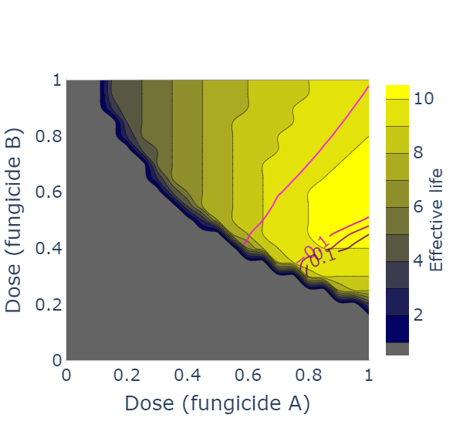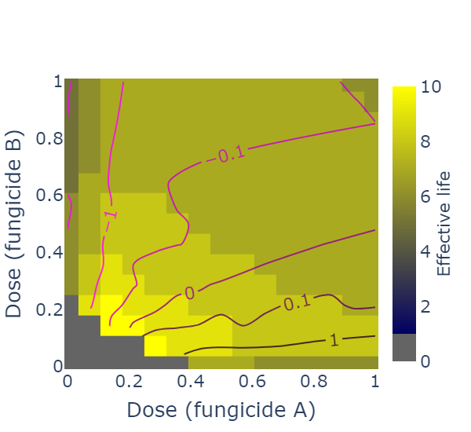

On left: full dose of a single fungicide is not sufficient for 95%. In this case sometimes ERFB doesn’t happen.

On right: full dose of either would be sufficient for 95%. ERFB always happens with this situation.

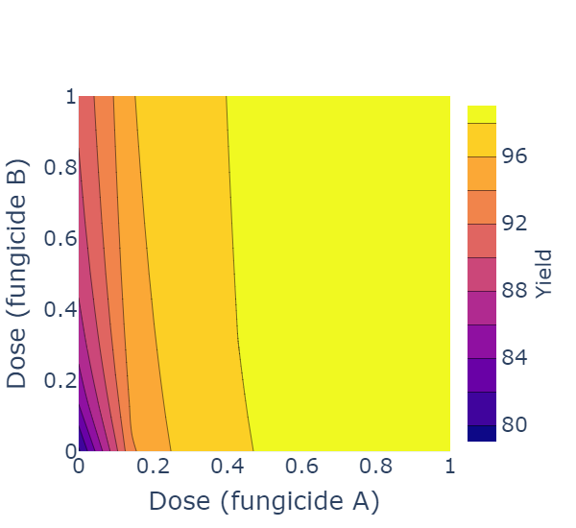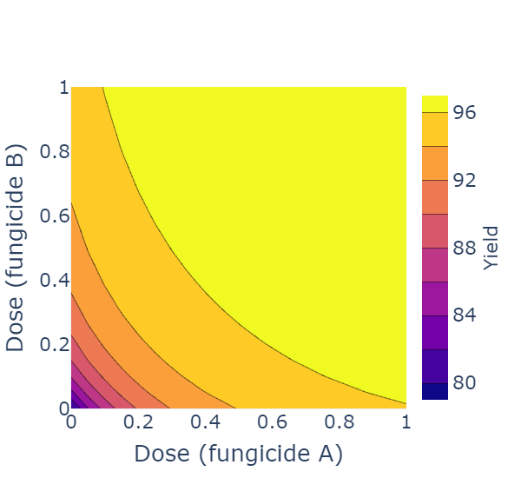

Here first year yield contours can vary a lot from k-x! Note that we ignore anything less than 95% on the first year yield.

When running the scans I took 20ish doses along 5ish contours between 95.01 and the maximum first year yield value (around 98 typically).

These doses shown don’t correlate with the previous heatmaps – haven’t had time to match up specific runs exactly but hopefully you get the idea.

UPDATE 02/05/2021

Could do grid scan. For each point – delta RFB, then FYY or MS or something

Plot for each run:

Heatmap: x: FYY; y: EL; z: delta RFB

Try to find link with opt MS depending on pathogen/fungicide/initial freq parameters.

Want something showing ERFB is good – and ideally that minimum RFB is best if ERFB not possible

Also want some idea of when to do high mixture strength is best.

If ERFB is possible we will always have a contour to go along – keeps things simple assuming ERFB works (almost) always?

RESULTS

Out of 300 (297) runs, 168 allowed ERFB, which were the only ones considered here.

ERFB:

Worked: 145/168=86.3%

Average: 97.0% (of the max across the grid)

>100%: 4 times (found a better value than the max on the grid)

Conditional mean: 76.9%

HOBB:

Worked: 60/112=53.6%

Average: 91.6%

>100%: 2 times

Conditional mean: 81.6%

FULL DOSE:

Worked: 37/168=22.0%

Average: 82.9%

>100%: 0

Conditional mean: 78.1%

MIN EQUAL DOSE:

Worked: 28/168=16.0%

Average: 74.5%

>100%: 0

Conditional mean: 69.4%